Emperor Pickletine Rides the Bus

Fifth Grade September

Breakfast Book Club

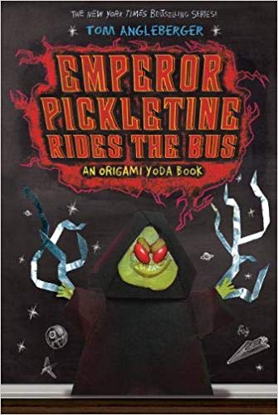

Read for Sept. 10th: pp. 1-59

Read for Sept.17th: pp. 60-113

Read for Sept. 24th: 114-205

7 am –ish in the Library

Bring your book!

Emperor Pickletine Rides the Bus

Fifth Grade September

Breakfast Book Club



Read for Sept. 10th: pp. 1-59

Read for Sept.17th: pp. 60-113

Read for Sept. 24th: 114-205

7 am –ish in the Library

Bring your book!

Emperor Pickletine Rides the Bus

Fifth Grade September

Breakfast Book Club



Read for Sept. 10th: pp. 1-59

Read for Sept.17th: pp. 60-113

Read for Sept. 24th: 114-205

7 am –ish in the Library

Bring your book!

Emperor Pickletine Rides the Bus

Fifth Grade September

Breakfast Book Club



Read for Sept. 10th: pp. 1-59

Read for Sept. 17th: pp. 60-113

Read for Sept. 24th: 114-205

7 am –ish in the Library

Bring your book!