Lilly – Helgeson, Caitlyn- Romano, Danny – Romano, Sarah –Beairsto, Ardyn- Janway, Noah F- Okhotskaya

Fenway and Hattie
Third Grade Library Book Club

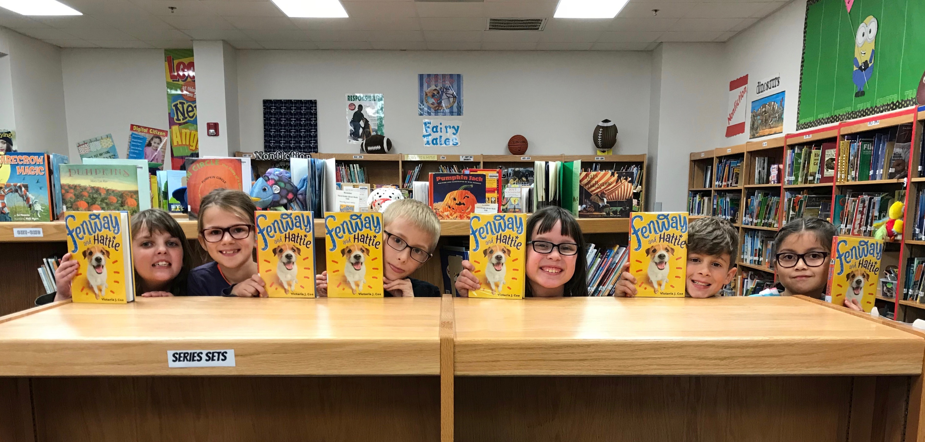
Read Ch. 7-13 before we meet
This Thursday, Nov. 16
2:55-3:45

Bring your book!

