 | A | B | C | D | E | F | G
1 |  |  | Steinbaugh  D120 | Shah  C 107 | Barker  C106 | C 101  Parra | Ms. Ngene
2 |  | D 119  Byrd |  | Cox  C109 | C108  LaChey |  | LIBRARY
3 |  | Hillier  D111 | Orensten  D118 |  | Maldonado  C114
4 |  | Belalcazar  D109 | Sagers  D110 | C115 | Vargas  C116
5
6 |  |  |  |  |  |  | ART
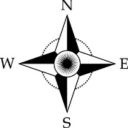
Map Legend
= Restrooms

= _____________

